Dorrington House Homes Statement of Purpose

Service Providers Steven & Lorraine Dorrington
Steven Dorrington |  |  | Lorraine Dorrington
 |  |  | 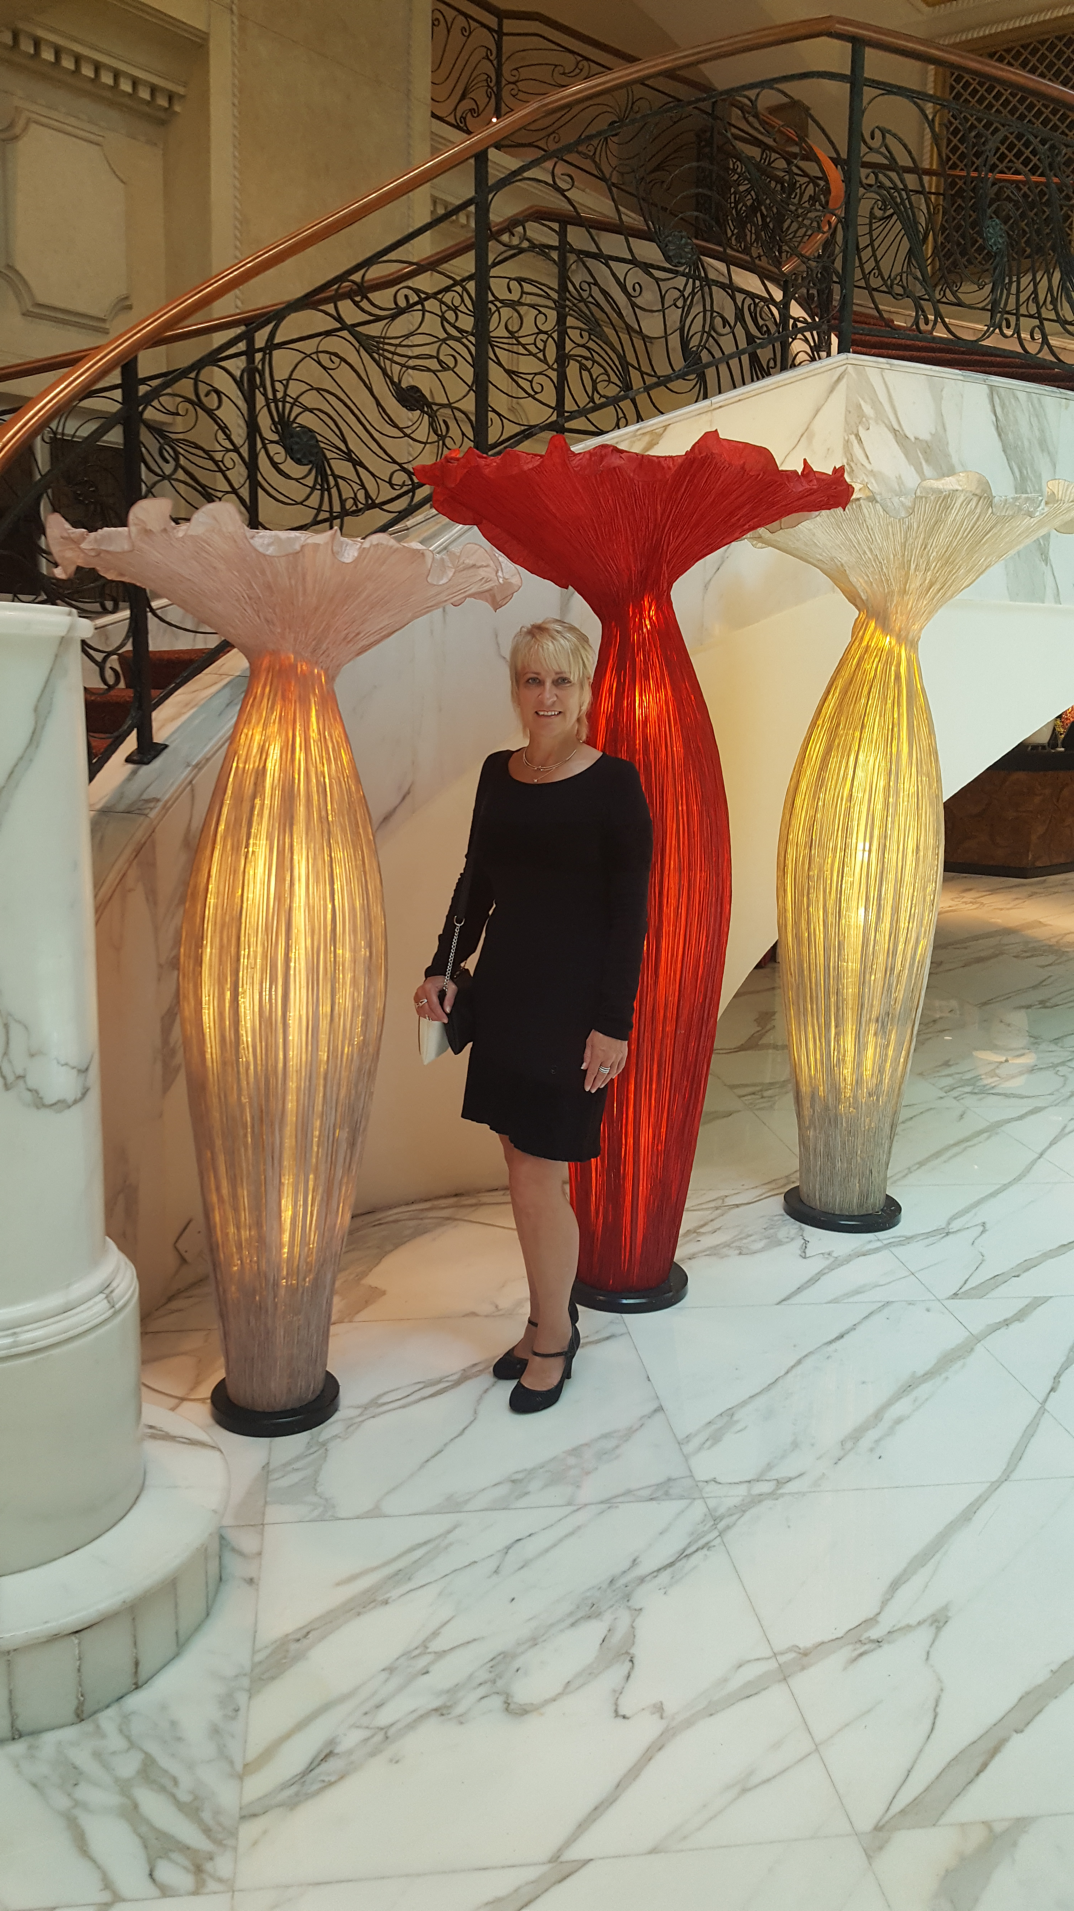
Head Office
28 Quebec Road
Dereham
NR19 2DR
Office: 01362-695840 & 693070
Steven: 07775-614200
Lorraine: 07768-881900

E-mail: steve@dorringtonhouse.com
lorraine@dorringtonhouse.com

Website: www.dorrington-house.co.uk

Statement of Aims and Objectives

Aims
- We aim to provide registered residential care accommodation for elderly people who may or may not have cognitive problems.
- We aim to provide and maintain a high standard of purpose-built accommodation.
- We aim to recruit and train staff who will respect the residents’ rights to choice, privacy, dignity, fulfilment, independence and rights irrespective of the residents’ range of abilities.
- We aim to operate services which are compliant with the Regulations at the time in force and exceed the Essential Standards of Quality and Safety.

Objectives

Our Objectives are listed under the five headings

- Ensuring the residents are safe

- Ensuring the service is effective

- Ensuring the service is caring

- Ensuring the service is responsive to people’s needs

- Ensuring the service is well-led

A. Ensuring the residents are safe
- Ensuring that the residents are protected from abuse and avoidable harm.
- Ensuring that the home is staffed adequately.
- Regularly reviewing our policies and procedures to ensure the safe handling and management of medicines and making sure that these procedures are followed by the staff who administer the medicines in our homes.
- Ensuring that our premises are designed, built and maintained in accordance with the requirements of all of the concerned Regulatory Authorities and any good practice guidance which may exist with respect to the residents’ needs.
- Using recruitment procedures which conform to the legislation which is in force at the time.
- Checking that our staff have the training necessary to ensure that they can understand the needs of the residents and how best to help the residents retain their rights of choice, privacy, dignity, independence, fulfilment, and rights. Facilitating this training where necessary.
- Making sure that if staff are not deemed fit to be employed the appropriate action is taken and the necessary notifications are made to the relevant authorities.
- Staffing our homes with people who have the right mix of skills to meet the needs of the resident populations.

B. Ensuring the service is effective
- Ensuring that the residents receive care which is appropriate to their needs and ensures their safety; support which helps maintain their independence and dignity.
- Providing meals which are to their choice and meet their nutritional needs; and staff assistance where necessary to ensure that meals are an enjoyable experience.
- Making sure that we are able, through positive relationships with other care providers, to work together with them to the benefit of the residents in our homes.
- Ensuring that the design, layout and maintenance of the home and its equipment, aids residents’ independence, dignity and privacy.
- Providing our homes with aids which may be required by the majority of the residents and ensuring that the equipment is regularly inspected and serviced by the appropriate individuals. Residents requiring custom equipment will be supported to obtain this from the appropriate agencies.
C. Ensuring the service is caring
- Ensuring that the care received by the residents is empowering.
- Ensuring that the staff treat the residents with dignity and respect.

D. Ensuring the service is responsive to people’s needs
- Ensuring that each resident has a care plan which details the care they need and that their care plan is regularly reviewed.
- Ensuring that the residents and their advocates, where appropriate, are consulted about the care plan.
- Ensuring that the policies and procedures respect individual preferences and rights.
- Ensuring that the staff at the home monitor all complaints and compliments and implement any remedial action where identified.
- Ensuring that the residents have the opportunity to be involved in any activities within the home according to their own interests and cultural beliefs.

E. Ensuring the service is well led
- Making sure that we publish our Statement of Purpose and review it regularly. The Statement of Purpose must be financially viable.
- Ensuring that we regularly review and monitor the quality of the service we provide in any of our Homes. We do this by a system of internal and external questionnaires, and we publish the results. Any areas of improvement identified will be implemented.
- Consulting with our residents/relatives and staff about any plans for changes and improvements to our services via regular forums, newsletters, notices, surveys etc.
- Networking with people who can advise us if there are situations beyond our current frame of reference.
- Encouraging all of the staff to be open to the opportunity of learning from any mistakes that we or they make. Our motto is ‘We can all make mistakes, but we must never make the same mistake twice’.
- Ensuring that we have systems in place which monitor and audit all aspects of the functioning of the homes and that any occurrences which are notifiable are reported to the relevant authorities, which includes CQC.

- Keeping all of the records that are required to be kept by all of the relevant regulatory authorities for registered residential care homes maintained for the legally required period of time. In respect to the individual care records for residents, this is three years but for some of the other records this is longer. The records must be easily retrievable.
- Recruiting good quality managers with the relevant range of experience and/or qualifications in place in each of the services we operate.
- Encouraging any manager who does not have the relevant qualifications to achieve these and to keep up to date with their training whilst in our employ.
- Keeping up to date ourselves so that we are able to effectively monitor our services, supervise and support our managers.

Dorrington House Homes
We have the same staffing structure in place in our three Homes

Dorrington House Homes
Dorrington House  Dereham | Dorrington House  Watton | Dorrington House  Wells-next-the-Sea
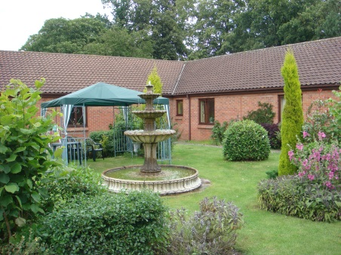 | 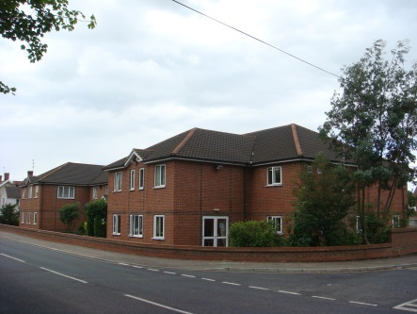 | 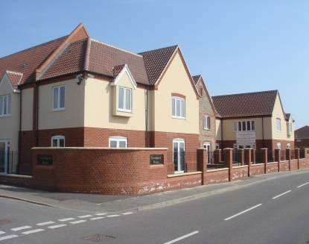
28 Quebec Road  Dereham  Norfolk  NR19 2DR  Tel: 01362 693070  Fax: 01362 697347  E-Mail: dereham@dorringtonhouse.com | 73 Norwich Road  Watton  Norfolk  IP25 6DH  Tel: 01953 883882  Fax: 01953 889035  E-Mail: watton@dorringtonhouse.com | Westfield Avenue  Wells-next-the-Sea  Norfolk  NR23 1BY  Tel: 01328 710861  Fax: 01328 713088  E-Mail: wells@dorringtonhouse.com
Manager:  Louise Hewitt  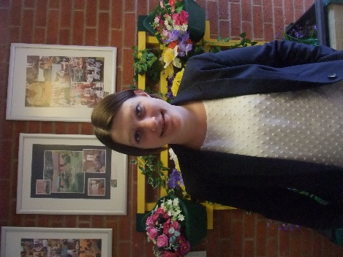 | Manager:  Cheryl McCulloch  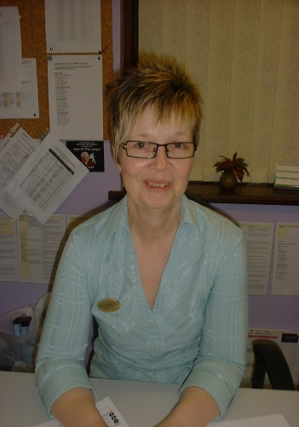 | Manager:  Sotak Rapley  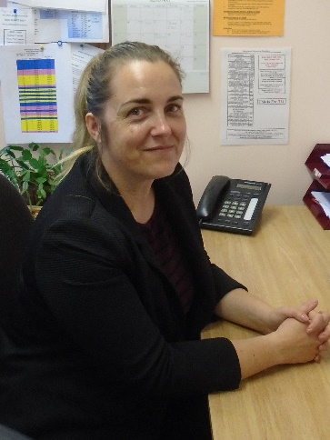
Registered 45 Beds | Registered 52 Beds | Registered 38 Beds

Dorrington House, Dereham

Dorrington House, Dereham provides residential care for up to 45 older people and older people with dementia type illnesses. It is situated close to the center of the market town of Dereham. The home comprises purpose-built ground floor accommodation in separate wings. Each wing has its own lounge, bathing and toilet facilities and in addition there are three shower rooms, a hairdressing salon and two treatment rooms plus a tuck shop trolley. All rooms are single and have en-suite toilet and hand basins. There are two communal dining rooms. There is an enclosed garden that is visible from some of the bedrooms and features a lovely water fountain.

The manager at Dereham is Louise Hewitt, she was appointed in April 2019. Louise has worked in care for over 12 years and is very passionate about providing good, person centered care. Louise has completed her Level 5 Diploma in Health and Social Care and various other qualifications relevant to her role including the Dementia Care coaching course.

Dorrington House, Watton

Dorrington House, Watton provides residential care for up to 52 older people including care for older people with dementia. It is situated close to the center of the town of Watton and within easy reach of its amenities. The home comprises purpose-built accommodation on two floors serviced by a shaft lift, stair lift and stairs, with 20 bedrooms on the ground floor and 32 on the first floor. All rooms are single and have en-suite toilet and wash hand basins in addition to the home's communal showers and bathrooms. There are other communal areas including hairdressing salon, tuck shop trolley, treatment room, conservatory, lounges and dining rooms that accommodate residents at meal times.

Cheryl McCulloch is the Manager at Watton and was appointed in March 2010, having been a deputy manager at the Dereham home for over 8 years. She has an NVQ Level 4 in Social Care as well as a Registered Manager’s Award. Cheryl has completed the Dementia wider picture and distressed behavior/ communication training course and Dementia and Challenging Behaviour training course.

Dorrington House, Wells-next-the-Sea

Dorrington House, Wells provides residential care for up to 38 older people and older people with dementia type illnesses. First registered in May 2008 it is situated close to the town center and within easy walking distance of Wells Quay which is a very popular seaside resort. The home comprises purpose-built accommodation on two floors and are single en-suite bedrooms, ranging in size from 13.6 sq m to 23 sq m. Some of the bedrooms enjoy spectacular views over the surrounding countryside and are of good size to have their own sitting/lounge area. There are 4 lounge diners all of which have kitchenettes that can be used by residents and their visitors, 4 assisted bathrooms, a shower room, 2 laundries, a hairdressing salon with door to patio area, a dedicated scooter/buggy charging room, a tuck shop, 2 treatment rooms, 2 lifts and 3 stairwells.

The Manager at Wells is Sotak Rapley. She was appointed as Manager in August 2017. Sotak has completed her Level 5 Diploma in Leadership in Health and Social care. Sotak has worked for us since November 2015 both at our Dereham and Wells Homes.
Sotak has completed the Dementia wider picture and distressed behavior/ communication training course and Dementia and Challenging Behavior training course.

