DORRINGTON HOUSE (Wells)
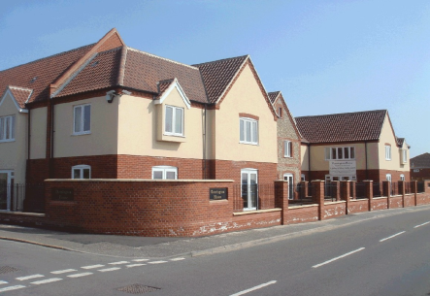

NEWS LETTER
Publisher: Corina Bindea Volume no. 6 Issue no. 1 Date: January 2015

Corina’s Column

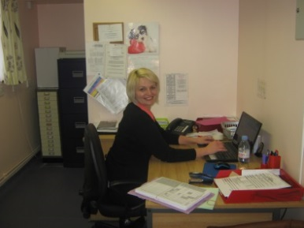

Dorrington House Homes
would like to wish you all a happy and prosperous 2015!

Hello Everyone!
We hope you have had a wonderful holiday season! Now, it is January and that time when many of us reassess our busy lives and think about what we want to accomplish or do to balance our lives during the next year.
As this is our first newsletter for 2015 it’s worth giving a mention to the vast array of events that took place at Dorrington House during December…
Christmas Raffle Results
Thank you to everyone who supported our Christmas Raffle and all other events. We raised a grand total of £345-00. The money raised went towards the entertainment for our residents. Thank you to all the staff too who helped over this holiday season it was much appreciated.

Staff Christmas Gifts
Staff are always grateful when residents and relatives show their appreciation by way of gifts, accordingly, many thanks for all the wonderful Christmas presents and money we were given, as you know we share all gifts, so each member of staff has received some chocolates, biscuits and wine from you.

Christmas Trees Festival
On Friday 13th December 5 residents and 2 staff went to visit the Decorated Christmas Trees at The Gordon Barrett Hall, there were 20 Christmas trees all decorated and done by local businesses and charities, we did one from the home too with the residents help to decorate it and were proud to see it displayed.

Christmas at Dorrington House
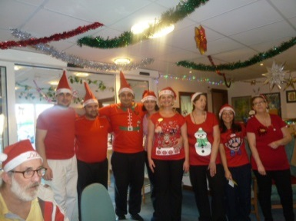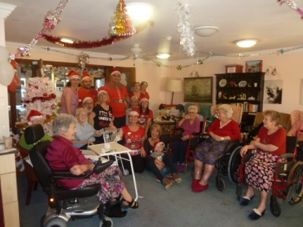
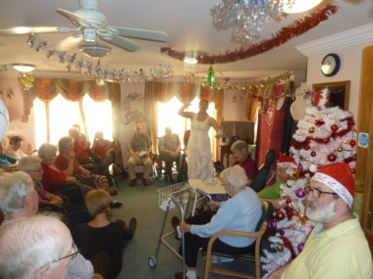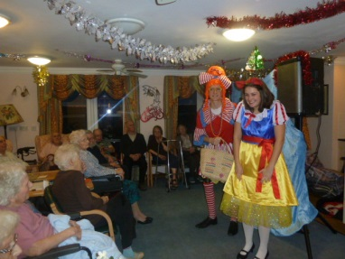
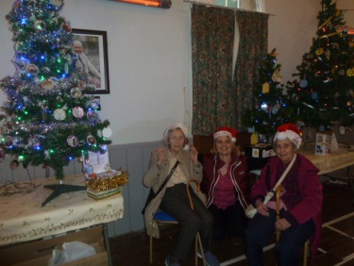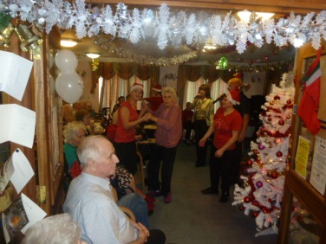
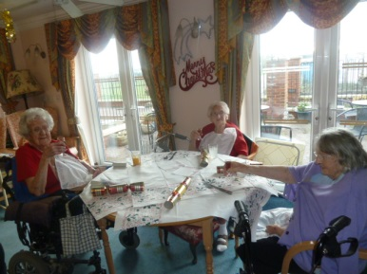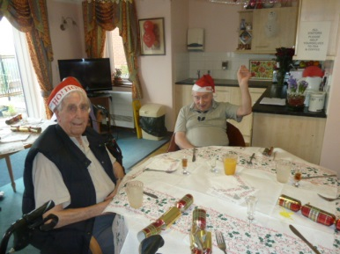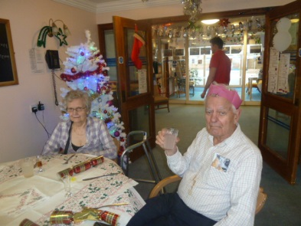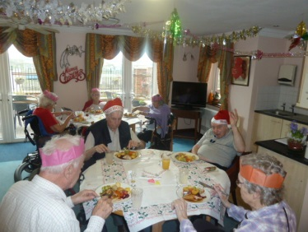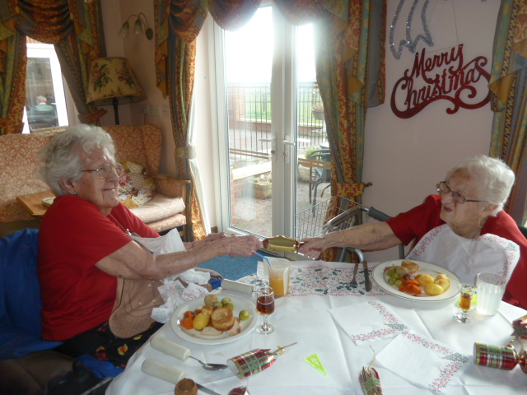

…it was a lovely Christmas and everyone enjoyed themselves, we had some wonderful entertainment throughout the month of December.
Well Done, Congratulations & A Big Thank You to EVERYONE for making Christmas & New Year such a lovely enjoyable time for all our residents.

January 2015 Events
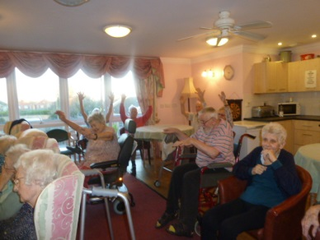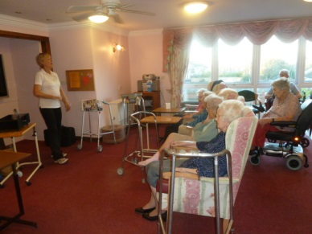
For the start of the New YearShelley from Extend Exercises came in for a leisurely but fun workout with our residents and staff, after the generosity of friends & relatives of fattening chocolates…!

Timescape
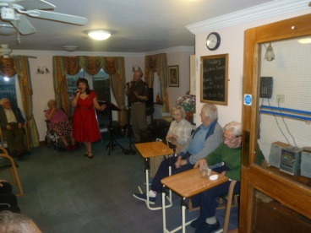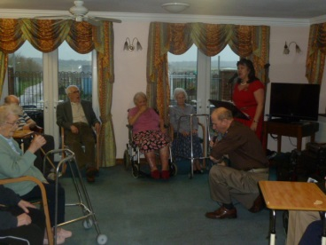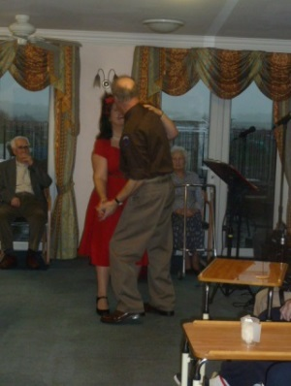
Our lounge was transformed back to the 1940-50’s by John & Chrissie of Timescape with John dressed as an American RAF who made the ladies swoon … it was a most enjoyable afternoon.

Art Class
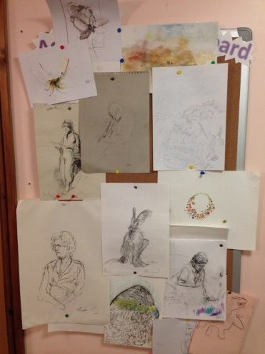
Our art class was well attended with very keen residents, it is a very good way of expressing themselves, they have achieved some very good work so far.

Dignity Action Day
1st February 2015
Dignity Action Day is an annual opportunity for health and social care workers, and members of the public to uphold people's rights to dignity and provide a truly memorable day for people who use care services.
Our aims are to put dignity and respect at the heart of Dorrington House. We think that everybody can do their bit to influence others and change the way care and support is delivered with the view that much of what needs to be done to advance this agenda “costs nothing”. It rather depends on simple principles such as treating people as individuals, listening and supporting them to
express their needs and wants and supporting them with the same respect that any of us
would want for ourselves or for a member of our families.
All our staff have been given a small credit-card sized document that sets out the 10 key
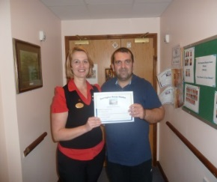
requirements underpinning the Dignity Challenge. These are:
1. Have a zero tolerance of all forms of abuse
2. Support people with the same respect you would want for yourself or a member of your
family
3. Treat each person as an individual by offering a personalised service
4. Enable people to maintain the maximum possible level of independence, choice and control
5. Listen and support people to express their needs and wants
6. Respect people's right to privacy
7. Ensure people feel able to complain without fear of retribution
8. Engage with family members and carers as care partners
9. Assist people to maintain confidence and positive self-esteem
10. Act to alleviate people's loneliness and isolation

Complaints & Compliments
We have recently updated our complaints and compliments policy and are placing a copy in every resident’s careplan and on each noticeboard in the home. If you have a concern or compliment please speak to a member of staff in the first instance. If you have a concern, by speaking to a member of staff it can then be resolved quickly and at an early stage. We take all concerns seriously and we always ensure that they are thoroughly investigated.
Congratulations to our Employees awarded
each Month
We have a monthly nomination scheme whereby residents, visitors and staff can fill in a form to nominate an employee if they feel they have gone above and beyond their usual job role. Forms can be found in reception.
October - Costy
For standing in as cook at very short notice in the absence of both cooks, doing it very well & with great good humour

November - Amanda
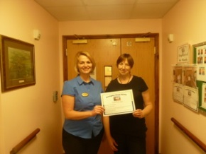
She is always willing to help everybody, always things ahead. She always has time for residents jobs asked, even when rushed. Does many services for residents over & above her normal duties
Keeping in touch…
Emails are checked daily, if you would like to send a message to your relative/friend then feel free to email us. We will ensure your email is printed and passed to the resident concerned,or read out on your behalf. Our email address is steve.dorrin@btconnect.com

Residents Birthday Celebrations

January:
6th Kathleen
23rd Margaret
25th Kathleen
30th Irene
February:
3rd Ken
10th Eric
12th Rosamund
12th Eileen
24th Brenda
27th Barbara
March:
26th Maurice
10th Dorothy

Bag2the future
…will be collecting from our home on 24th February 2015. Please bring your bag (or bags!) with clothes (this can include adults and children’s clothes, shoes (tied together please), hats, belts, bags, soft toys.) to Dorrington House Wells before this date and help us have a really good collection. We will receive £500 per ton or £0.50/kg which will be a great boost for our fundraising.

Friends of the Home Appeal
Our Friends of the Home funds were getting low, and we reached out to friends and relatives for their support, we have been overwhelmed with the amount of support we have received & received many cheque donations for our fund.
We can now progress forward into booking entertainment for our residents to enjoy.
Thank you for responding so quickly to our appeal, Thank you for all the donations!


Date’s For Your Diary
We hope you will be able to come and join us, and we look forward to seeing you there!
Tina Reed our Hairdresser comes in every THURSDAY
Tina Barnes the Foot Health Specialist comes in once every 6 weeks.
*The first Tuesday of each month is Extend Exercises at 2.15pm
*The second Wednesday of each month is Holy Communion at 2.30pm

*The Third Wednesday of each month is Church Services at 2.15pm

*Friday 9th January at 2-30pm “Art Class”
*Tuesday 13th January at 3 pm Timescape ‘Sentimental Journey’
*Friday 16th January at 2pm – Residents Forum

*Friday 23rd January at 2-30pm “Art Class”
*Tuesday 27th January at 2.30 pm Richard Lowe entertainment – local Norfolk Songs.
*Friday 30th January – Dignity Action Day ‘Cream Digny tea afternoon’
*Monday 2nd February - Handbag sale 2.30pm
*Friday 6th & 20th February – Art Class 2.30pm
*Monday 9th February – Ken –songs and poems
*Friday 13th February 3-4pm Mike & Helen Entertaiment fallowed by Corina’s Valentine’s delicates
*Monday 16th February Richard Newman entertainment 2.30pm
*Monday 23rd February 2.30 pm Richard Lowe entertainment – local Norfolk Songs.

