DORRINGTON HOUSE (WATTON)
TEL: 01953 883882 or E.MAIL: dhwatton@btconnect.com
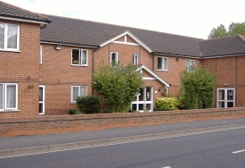

NEWS LETTER

Publisher: Linda O’Riordan Volume no. 6 Issue no.1 Date: January 2015

Cheryl’s Column

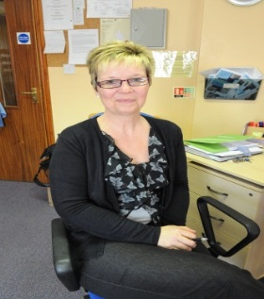
Hi Everyone,

We hope this, the first of the New Year’s newsletters, finds you all well and having enjoyed a lovely Christmas and New Year.
We have had a brilliant time here in the run up to Christmas with lots of entertainment and dress up days for everyone to get involved with.
Residents also enjoyed toasting in the New Year with Bucks Fizz and Sherry when Big Ben struck midnight!
Happy New Year Everyone!

Cheryl

Residents Birthday Celebrations

JANUARY:
Michael H 13th, Kathleen F 23rd,
Kenneth J 24th,
FEBRUARY: Mary R 22nd.
MARCH: Joy A 2nd, Rose L 7th, John N 10th, Beryl T 14th, Hazel B 14th, Valerie G 19th, Joan Shorthose 21st, Jim D 26th,
“Happy Birthday & Very Best Wishes To You All”

Recent Events in the Home
Razamatazz
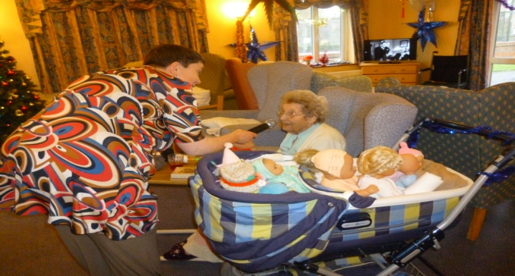
On 11th December we had a visit from Carolyn Harding and her Razamatazz Show, pictured above is resident Connie having a singalong into the mike with Carolyn.

Resident’s Christmas Party
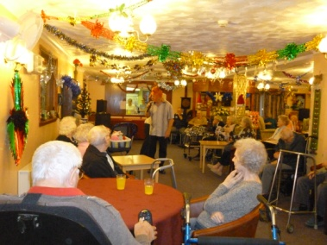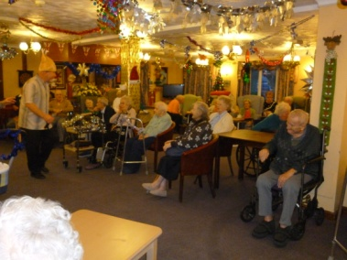
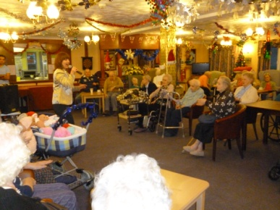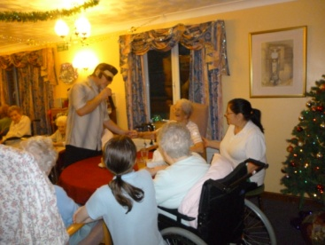
Our Residents Christmas Party was Wednesday 17th December and we started at 3pm with music and entertainment from Helen & Mike and residents boogied away the afternoon having a great time! Entertainment was followed by a wonderful buffet tea which everyone said was delicious.

...And The Christmas Raffle
Thank you to everyone who supported our Christmas Raffle’s by either buying tickets or donating prizes or both!! We raised a grand total of £136.00 for our Resident’s Funds.

…And The Champagne!
A BIG THANK YOU to a residents’ husband who donated a lovely bottle of Bollinger Champagne for a raffle prize, we raffled this off separately and raised £21.00!

…And The Dress Up Day!
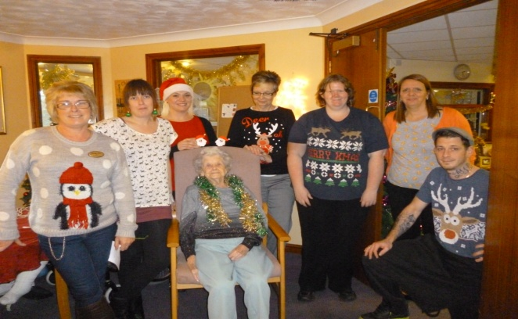
Pictured above staff and resident Nellie getting into the spirit of things by dressing up for christmas and raising funds for Friends of the Home.

Extend Exercises
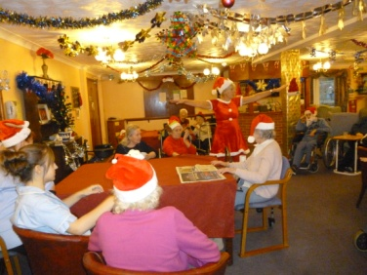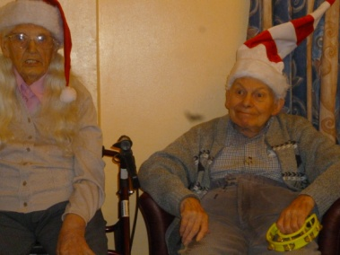
On Monday 1st December Shelley kicked off the Christmas Festivities with her special Christmas Extend Exercise Class dressed as Santa’s little helper and brought with her a variety of christmas hats for residents to wear whilst they exercised which was a great hit!

Christmas Day Lunch
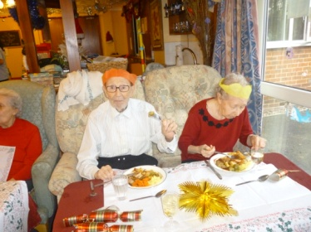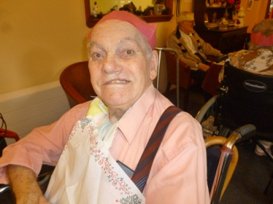

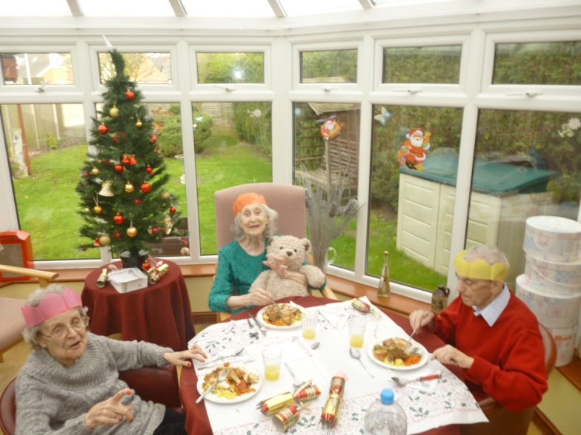
Christmas Day Lunch was a great celebration with everyone eating lunch together in the main lounge and conservatory. Residents commented that it was like a big family Christmas with everyone sitting together and crackers being pulled! A super day was had by all.

Christmas Presents
Steve & Lorraine Dorrington kindly bought 4 new DVD players for the lounges throughout the home and we hope that we can re-create some cinema magic for our residents with Cowboy films, Audrey Hepburn films and lots of the other favourites that everyone remembers.
FOH also brought every resident a selection box for them to unwrap and enjoy on Christmas Day and some Baileys!
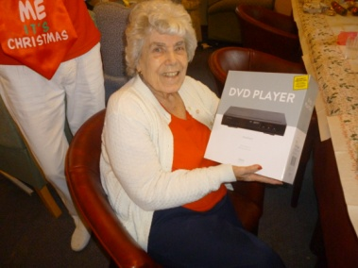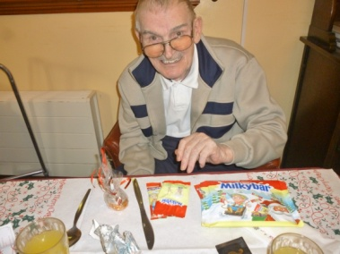
Residents also raised a glass (or two) of bubbly Bucks Fizz to the New Year 2015!
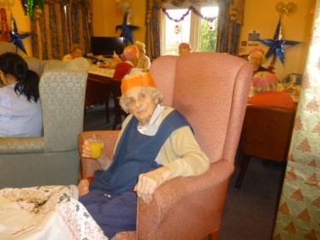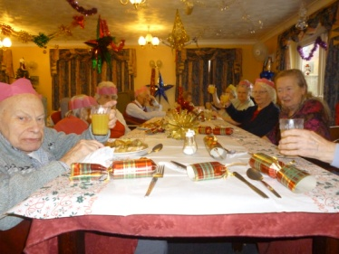
Christmas Hats
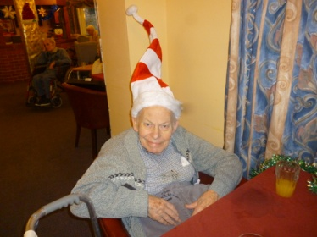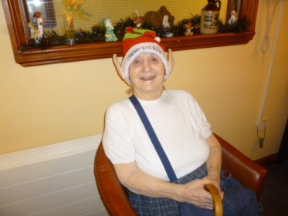
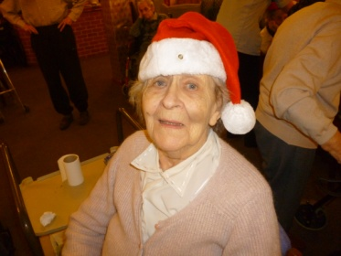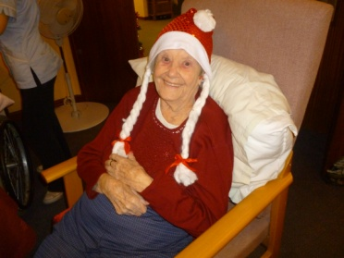
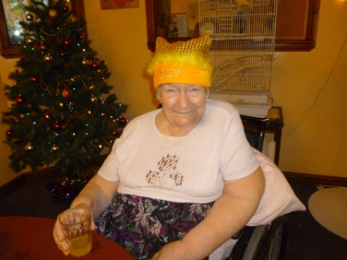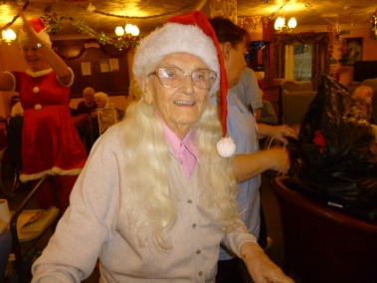
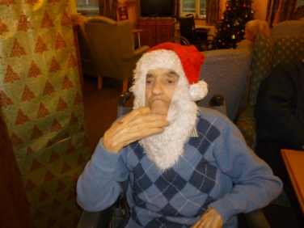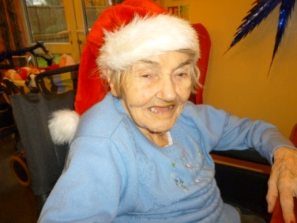
Resident’s with their Christmas hats on! From top left: Dennis R, Gladys G, Rose L, Nellie M, Sylvia T, Mary R, Robert L, Winnie C.
Employee Of The Month
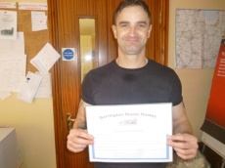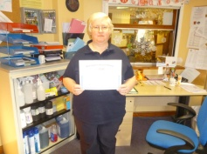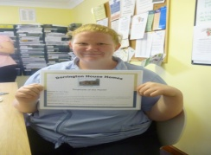
October 2014, Cristian, is a hard worker who always makes sure all tasks are complete and resident’s needs are met, always happy and cheerful around the residents.
November 2014 Eileen, works hard to make sure everything is done, always ready to help her colleagues when an extra pair of hands is needed, always cheerful with a smile for residents and staff.
December 2014 Zoe, is a much valued member of the DH team. Always ready to help out where needed and relied upon when keyholding. Brightens the resident’s days.
Well Done & Congratulations To You All! Residents and Relatives can nominate staff and forms are available in reception.
Our Kitchenette
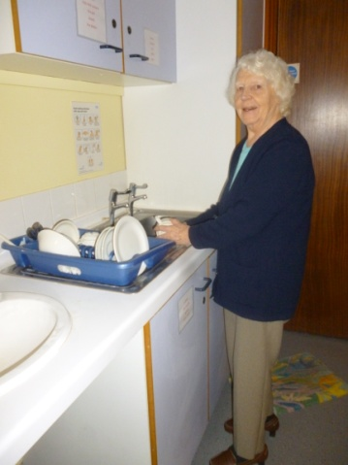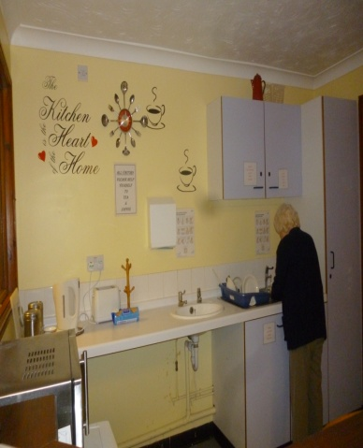
Pictured above is resident Iris making good use of our newly revamped kitchenette (which is on the first floor just around the corner from the lift). Iris spent some time in the kitchenette making her own breakfast and coffee and it was lovely to see her maintaining her independence by being able to do this for herself. The kitchenette is there for residents and visitors to use whenever you like, it is always fully stocked with everything that you will need to make a cuppa during your visit, so please feel free to help yourself!
Dates For Your Diary
Tuesday’s every week, All Day - Tina the Hairdresser
3rd Wednesday of every month – 10.30am Holy Communion
2nd Monday of every month - 11am Residents & Relatives Forum
1st Monday of every month – Extend with Shelley – Gentle Exercises
05.01.15 – Extend with Shelley at 1.30pm
08.01.15 – Nostalgia Film Show at 2pm
16.01.15 – Gerry Morris at 2pm
21.01.15 – Holy Communion at 10.30am
30.01.15 – Razamatazz at 2pm
02.02.15 – Extend with Shelley at 1.30pm
14.02.15 – Gerry Morris at 2pm
14.02.15 – Valentines Day
02.03.15 – Extend with Shelley at 1.30pm
10.03.15 – Music for Health with Linda Stretch at 2pm
27.03.15 – Razzamatazz Show with Carolyn Harding at 2pm
Any further dates for entertainment will be advertised on the noticeboard’s throughout the home so keep your eye on them and you are always very welcome to join us for all activities.

Sylvie’s Lovebirds…..
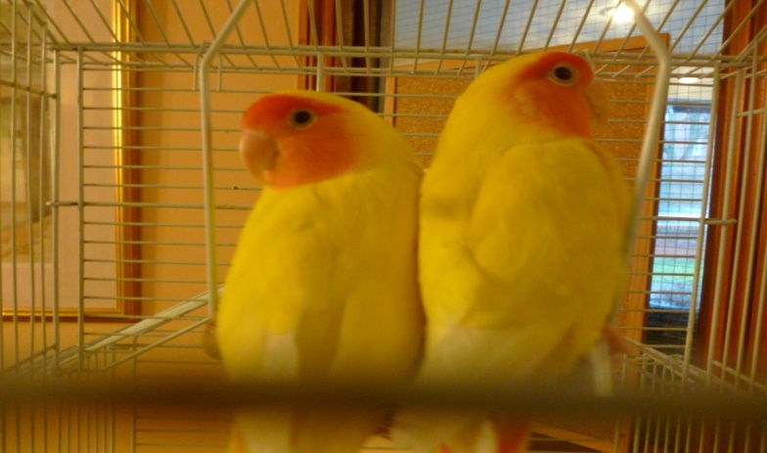
We have adopted the beautiful lovebirds that came to live with us with the late Sylvia T.
Our residents and staff absolutely love the pair of sweethearts and since they have been here they have brightened up many a day for everyone. As we are only finding our way in the art of birdkeeping, if anyone has any advice on keeping them at their best we would be only too happy to hear it!

Relatives Donations
We are very happy to announce that the family of our late resident Minnie are continuing their generous donation by paying for an entertainer for the residents this year. Michael and his family are paying for 6 visits from Gerry Morris who is always very popular with the residents.
We received a cheque for £100 from Cliff, the son of our late resident Stanley and a £50.00 donation from a residents’ family.
All our thanks to these generous families who have started our new year off with such kindness.

Communication
If you would like us to send you our correspondence by email please drop us a line at the following address dhwatton@btinternet.com and we will update our records with your contact preferences.

Complaints & Compliments
We have recently updated our complaints and compliments policy and have placed a copy in every resident’s careplan and on each noticeboard in the home. If you have a concern or compliment please speak to a member of staff in the first instance. If you have a concern, by speaking to a member of staff it can then be resolved quickly and at an early stage. We take all concerns seriously and we always ensure that they are thoroughly investigated.

We have great pleasure in welcoming our new carers; Alina, Philip & Leanna.
We hope you all enjoy working here at Dorrington House Homes

And Goodbye to carers Martin, Julie & Becky.

