DORRINGTON HOUSE (Dereham)

NEWS LETTER

Publisher: Chrissie Rose Volume no. 6 Issue no.1 Date: January 2015

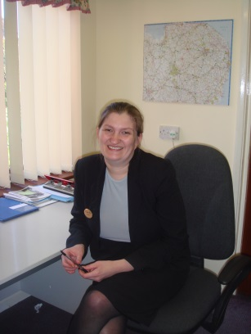
Hi everyone and welcome to our first Newsletter of 2015! May I firstly wish everyone A Very Happy New Year from myself and all my team and welcome to all our new residents, relatives and loved ones reading our newsletters for the first time.

After a very busy time over the Christmas period we are all looking forward to another exciting year, hoping for some good weather in the coming months to help us enjoy our many activities and events we have planned for the coming months ahead. If anyone has any new suggestions for entertainers or fund raising ideas, please let us know.

Some of our events from 2014

Our Halloween Party

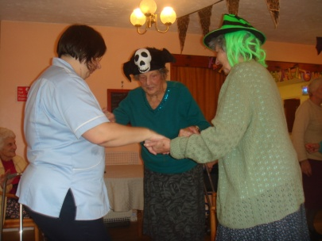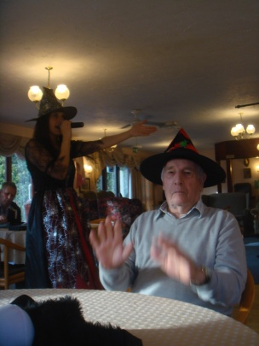
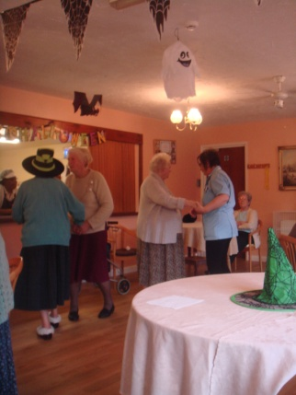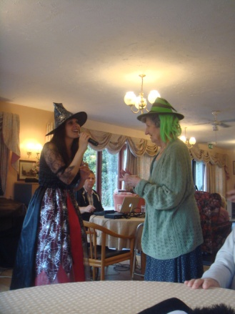

Come Lunch with us

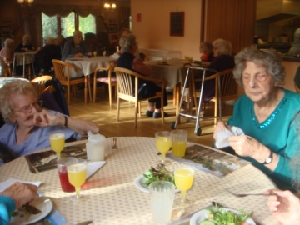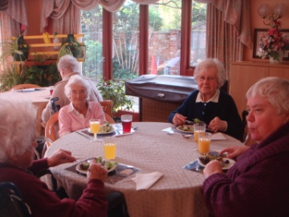

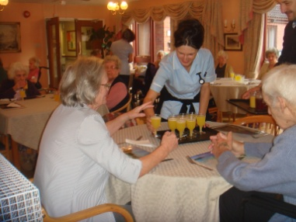

Music for Health
With Linda

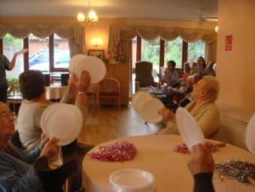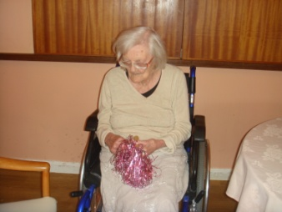

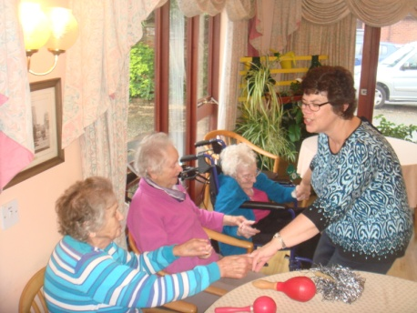

Tickled Pink
Christmas Spectacular
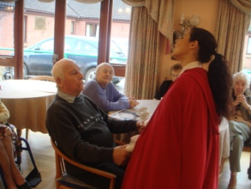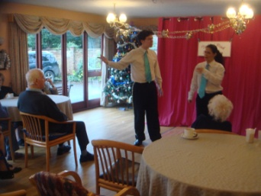

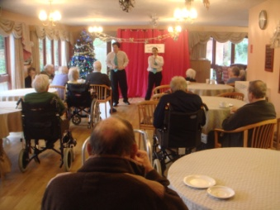

Santa dropped by on
Christmas Morning to deliver parcels to everyone

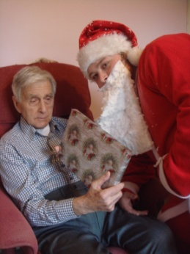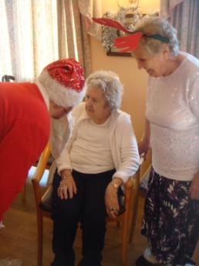

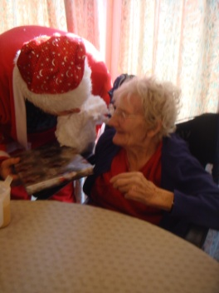

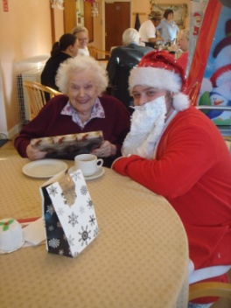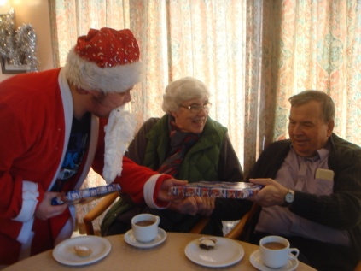

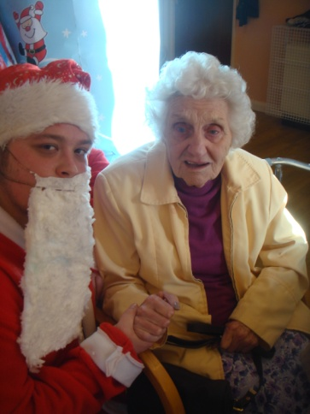

Our Christmas Coffee Morning
&
Residents and Relatives Christmas Party Celebrations

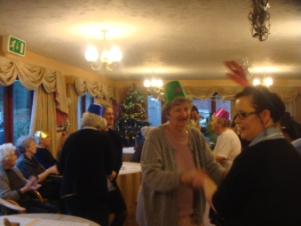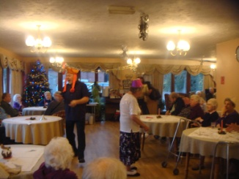

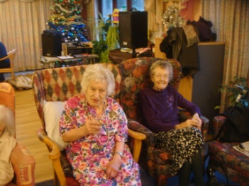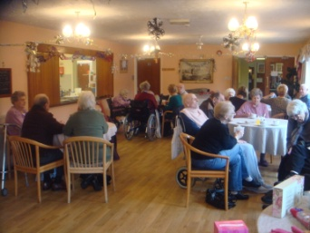

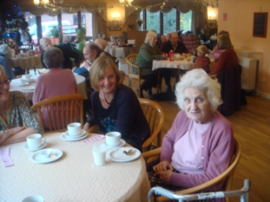

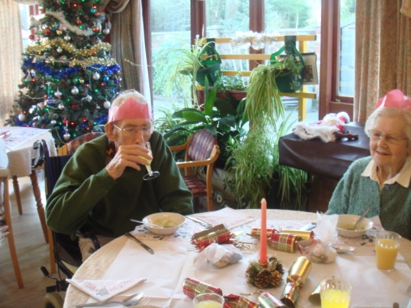

Congratulations
to Claudia & Alison on their promotion
to Senior Carers

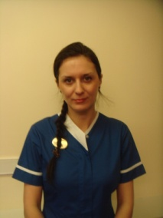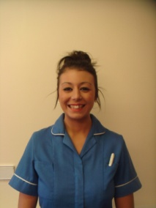

Bags to the Future
Next Collection 6th March



Please bring us your unwanted Clothing, Bedding, Curtains, Soft Toys, Shoes, Belts and Handbags (Sorry no bric-a-brac) to help boost our Friends of the Home Funds.
A big thank you to everyone
for your continued support

Welcome
Welcome to our new Carers Edith & Gabriela and new Support Worker Patrick, we hope you enjoy your new positions with us all.

Goodbye
Good luck to Natalie & Tracey
who have recently left.

Congratulations!


Congratulations to Carer Lorraine on the birth of her beautiful little boy Ethan, we wish you all the best.

Employee of the Month

November 2014
Carol works really hard to ensure the cleanliness of the home is kept up to a good standard.

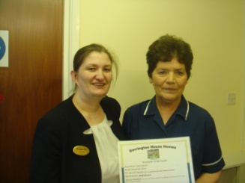

December 2014
Tamas works really hard to ensure the cleanliness of the home is kept up to a good standard.

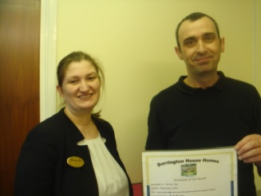

January 2015
Cosmin works really hard to ensure the cleanliness of the home is kept up to standard.



If you wish to nominate an Employee as you feel they have gone above and beyond their job role, forms are available in the foyer or from the office.

Room Vacancies

We currently have rooms available for residential care for older people and for older people with dementia. Please speak to Chrissie, Deb or the senior carer on shift or telephone 01362 695840 or email dhdereham@btinternet.com

Care Quality Commission
Registration

Chrissie was successful in her interview with the Care Quality Commission and is now the Registered Manager for Dorrington House Dereham.

Birthdays

January
6th Mary O
7th Neil W
7th Irene W
28th Alfred N

February
1st Rankin C
8th Peter W
17th Doreen P
22nd Joyce C

March
1st Ann B
4th Dorothy C
13th March
25th Cilla K

Career Vacancies

We have employment vacancies for Health Care Assistants and a Domestic Assistant, if anyone wishes to apply please visit our website where you can complete your application online. You can also contact us via the office on 01362 695840 or via email dhdereham@btinternet.com

Entertainer
Elaine Denny
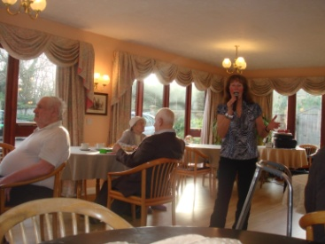

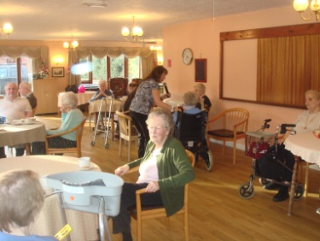

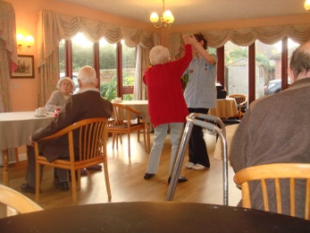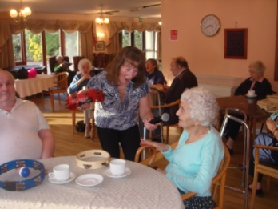

Friends of the Home

Thank you to everyone for your continued support throughout 2014, generously giving donations, raffle prizes and giving up your free time to help during our fund raising events, your continued support is always very much appreciated

Thank you

Forthcoming Events
Dates for your diaries

Everyone is welcome to come along to any of our events; please keep an eye on our notice boards for further details of events.

Valentines Come Dine With Us
Come along and join us on
Saturday 14th February from 12.30
Tickets Available from the Office
£5 each


Songs by Paul Wortly 28th January @ 2pm
Razzamatazz 3rd February @ 2.30 pm
Church Service 6th February @ 3pm
Residents & Relatives Forum 16th February @ 11.00am
Church Service 6th March @ 3pm
Music for Health 10th March @ 10.30am

Easter Coffee Morning 25th March
@ 10.30 am
Zootastic 14th April @ 2pm
Residents & Relatives Forum 20th April @ 11.00am

Computerised Careplanning
Over the next few months we are installing a computerised system for Care planning. This is the way forward for Care Homes and very well received with the CQC.
We have Lawrence, Eddie, Aaron and Shane as support to help and assist staff with using the new computerised system.

Close Care Flats
We have vacancies in our Close Care Flats for residential care for older people. Please call and speak to Chrissie or Deb for more information.

Residents & Relatives Forums Our Residents and Relatives Forums are held every third Monday of the month in our Main Lounge, everyone is welcome to come along and join us.

Contact details
Telephone 01362 695840 PLEASE NOTE THIS IS THE NUMBER TO RING.
THE OTHER NUMBER: 01362 693070 IS AN ANSWERPHONE ONLY.
Email dhdereham@btinternet.com
Website www.dorrington-house.co.uk and click on the Dereham logo

Complaints & Compliments
We have recently updated our complaints and compliments policy and have placed a copy in every resident’s careplan and on each noticeboard in the home. If you have a concern or compliment please speak to a member of staff in the first instance. If you have a concern, by speaking to a member of staff it can then be resolved quickly and at an early stage. We take all concerns seriously and we always ensure that they are thoroughly investigated.

